29.50:a) Rotating about the 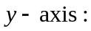
b) Rotating about the 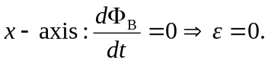
c) Rotating about the 